Refrence sheet for New RHEL-9 Master media Config.—

Me1-

Note: in POD45 Media servers(1) having a gateway on ENS224(VLAN) & ENS192 don't have gateway

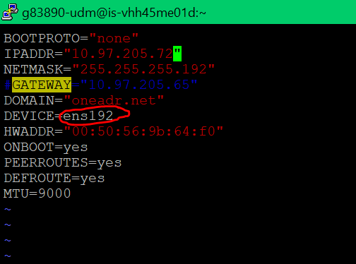

Me2--

**in POD45 Media servers(2) having a gateway on ENS192(VXLAN) & ENS224 don't have gateway.**



